1. Servlet Definitions.
2. Servlet component.
3. Servlet API version.
4. Important Resources of servlet API.
5. Different Approaches to develop the servlet component.
6. **Servlet Definitions:-**

Def1:- Servlet is java based and Thread based server side web technology. It is used to develop the dynamic web components.

Def2:- It is JEE Module web technology that extends the functionality of web server or web container to processing the request and generating the response.

Def3:- It is JEE Module server side web technology that allows us to develop “single instance multiple thread based server side web components”.



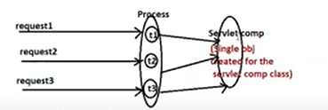

Def4:- It is JEE module server side web technology that provides the API for vendor companies as rules and guide lines to create servlet container software and provide same API for developer to develop the dynamic web component in java web applications.

1. **Servlet Component/Servlet Program**:-
2. It is a dynamic web component that is created by using servlet api of servlet technology.
3. It is java class that is implementing the

javax.servlet.Servlet(I) interface. or

Jakarata.servlet.Servlet(I)

Directly or indirectly.

1. **Servlet API Version:-** The latest version is 5.x.

This api have the following packages.

a. Jakarta.servlet

b. Jakarta.servlet.http

c. Jakarta.servlet.annotation

d. Jakarta.servlet.descriptor

Note:- In servlet 5.x version, javax was replaced with Jakarta.

1. **Important Resources of Servlet API:-**

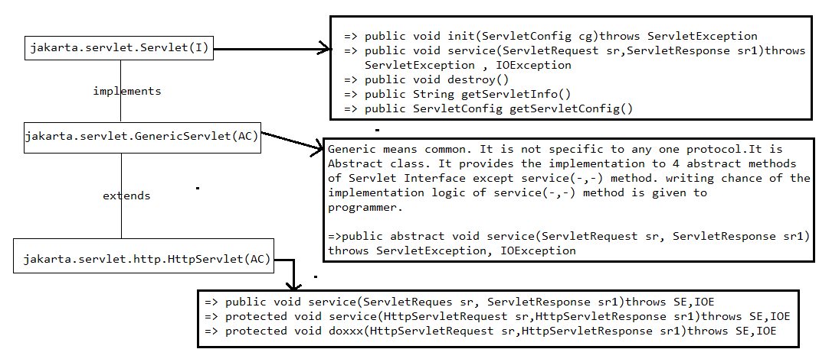

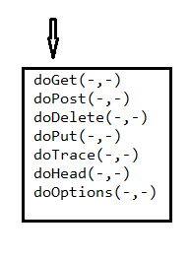

**Note:-** HttpServlet is specific to “Http” protocol. All “http” protocol features can be used in this class. The feature is “auto refresh” of web page. This feature is useful in “live score updating” and “ share market trading web pages”.

* 1. Service(-,-) method:- The programmer writes request processing logic in the service() mehod.

Syntax:-



The request object of service(-,-) method is very useful to collect the inputs that are coming along with request given by browser.

The response object of service(-,-) method is very useful to send service method generated results to Browser as response.

**5.Different Approaches to develop the servlet component**:-

5.1. Approach:- Take the servlet component class implementing the Jakarta.servlet.Servlet(I) and provide the implementation for all 5 methods.

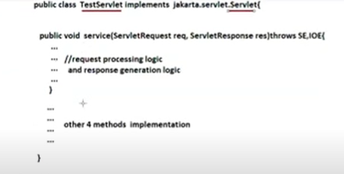

Disadvantage:- 1.The programmer is forced to place definition for all 5 methods. This is burden to programmer. Therefore Every body does not recommend the First Approach.

Realtime Example:- In college days, I invited the girl friend to party. She said that “ I would not come with u alone So u should also invite my friends then only I will come”. Now I thought very burden giving the party to other friends.

Now My situation and Programmer situation is same.

2. we can’t use “http” protocol features in servlet component class.

5.2.Approach-2:- Take the servlet component class which implementing the Jakarta.servlet.GenericServlet and provide implementation for only service(-,-) method.

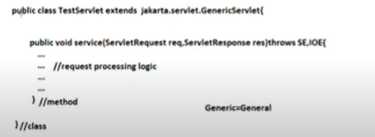

Disadvantages:-we can not use “http” protocol features(auto referesh) in servlet component class.

This approach is also not recommended to develop the servlet component class.

5.3 Approach-3:- Take the class which extends the Jakarta.servlet.HttpServlet and override the one of the service(-,-) method and one of the7 doxxx(-) method having the request processing logic.

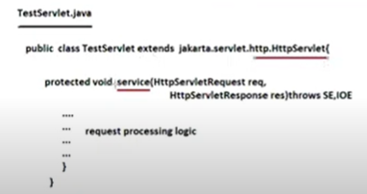

Advantages:-

